IoT Lab 2

**Name:** Cao Xinyang

**HDU Number:** 20321308

**My Photo:**



**Job issue for the work:**

1.Use the created model of intersections.

2.Create animation (cars flows).

3.Perform experiments aiming to discover the bottlenecks.

**Parameter and its function:**

**carSource:**

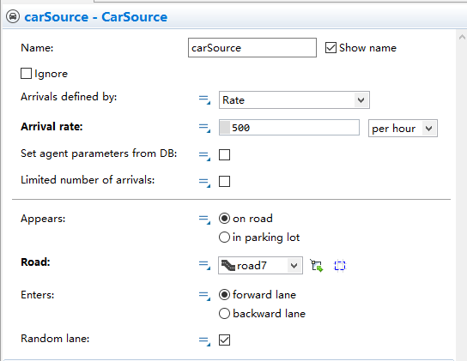

**Arrival rate:** Set the amount of traffic per hour

**Road:** Set the starting point of the traffic flow

**Appears:** Set whether the car should park into the parking lot

**Enters:** Set whether the traffic flow is generated at the front or back end of the road

**carMoveTo:**

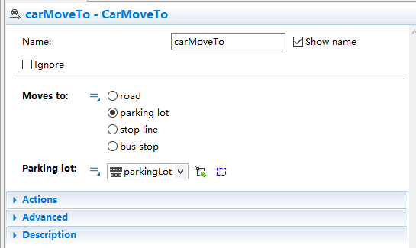

**Moves to:** set the type of the place where the traffic flow ends

**The second parameter** is used to set the ending point of the traffic flow

**delay:**

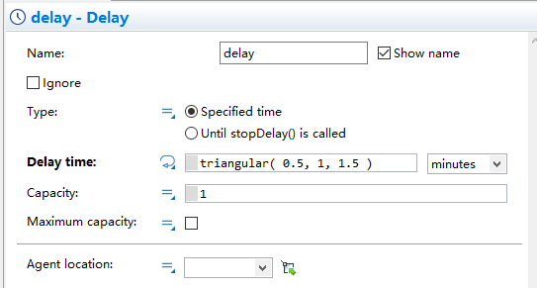

**Delay time:** Set the time the vehicle stays

**carDispose:**

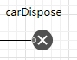

Make the vehicle disappear

**My model:**

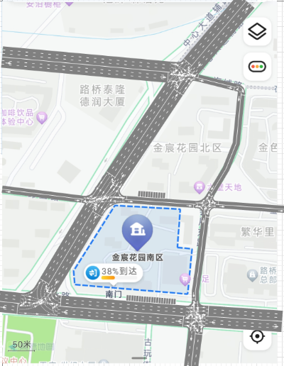

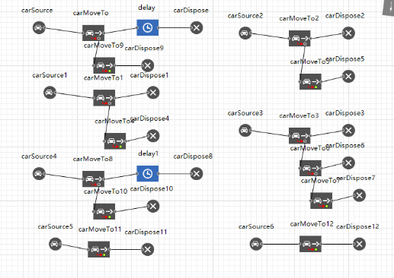

**Running time:**

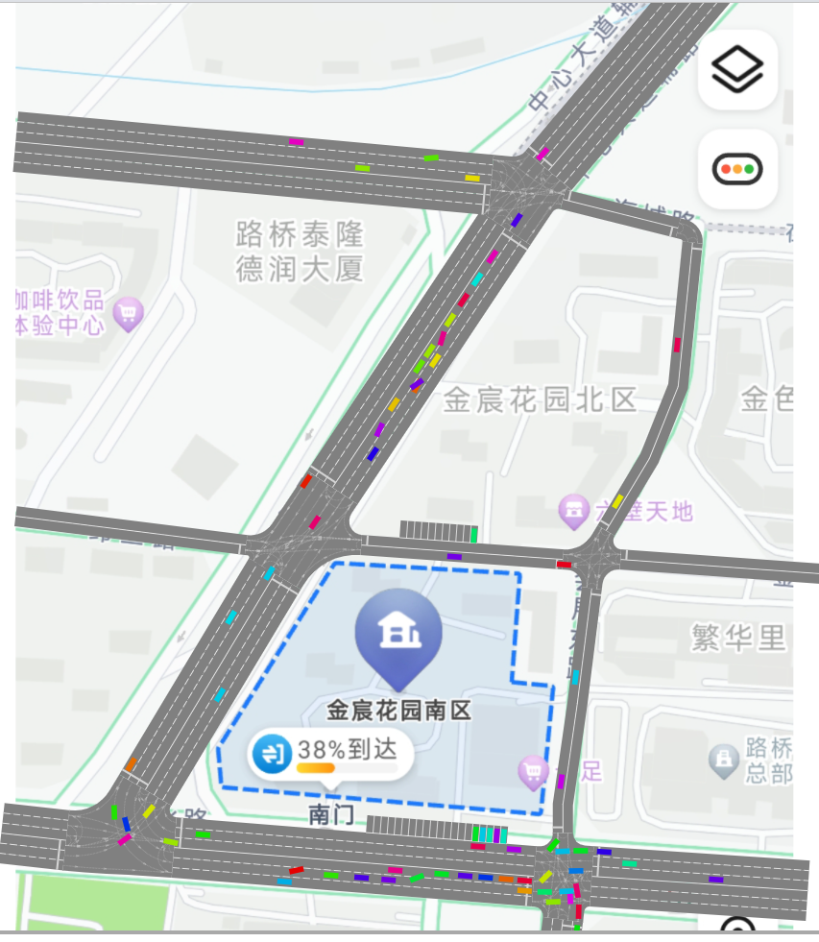

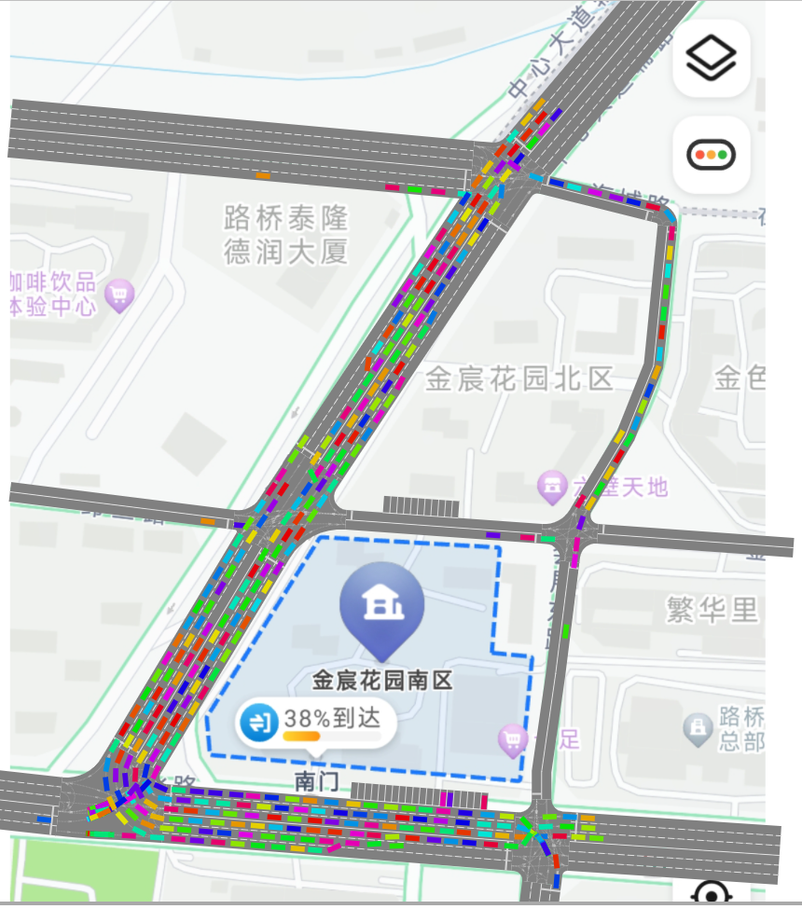

**Conclusion:**

During this lab, we have learnt how to use the software AnyLogic to build the model of the road and create traffic flows. AnyLogic is a good software to simulate the situations of the traffic. By using this model, we are able to build the traffic flows and see how they can run.

But we can see that the traffic without traffic lights has high probability to have traffic jams. So in the next lab, we may have to try to use traffic lights to avoid such situation.